SELENIUM WEBDRIVER - HANDLING DIFFERENT CONTROLS ON WEB PAGE - ADVANCED

Course: Selenium Web Automation Training
Module / Week: Week 1 Assignment

1. HANDLING ALERT BOX
JavaScript popups and modal dialogs (alerts, prompts, confirms) interrupt DOM execution
and must be handled using Selenium’s ‘switch_to.alert’ interface.

A. TYPES OF ALERTS:
- Simple Alert: Displays an informational message with an 'OK' button.
- Confirm Alert: Displays a confirmation prompt with 'OK' and 'Cancel' buttons.
- Prompt Alert: Displays an input field with 'OK' and 'Cancel' buttons.

B. SYNTAX & METHODS:
- Switch to alert: alert = driver.switch_to.alert
- Get alert text: message = alert.text
- Accept (Click OK): alert.accept()
- Dismiss (Cancel): alert.dismiss()
- Send text (Prompt): alert.send_keys("Text Value")

C. EXPLICIT WAIT BEST PRACTICE:
HTML code
<button onclick="alert('Hello Selenium')">
Click Me
</button>

#Python
from selenium.webdriver.support.ui import WebDriverWait
from selenium.webdriver.support import expected_conditions as EC
wait = WebDriverWait(driver, 10)
alert = wait.until(EC.alert_is_present())
print(alert.text)
alert.accept()

HTML code
<!DOCTYPE html>
<html>
<head>
<title>Alert Example</title>
</head>
<body>
<button onclick="alert('Hello Selenium')">
Click Me
</button>
</body>
</html>

#Python
from selenium import webdriver
from selenium.webdriver.common.by import By
from selenium.webdriver.support.ui import WebDriverWait
from selenium.webdriver.support import expected_conditions as EC
driver = webdriver.Chrome()
driver.get("file:///C:/path/alert.html")
# Click the button that generates the alert
driver.find_element(By.XPATH, "//button").click()
# Explicit Wait
wait = WebDriverWait(driver, 10)
# Wait until alert is present
alert = wait.until(EC.alert_is_present())
# Get alert text
print(alert.text)
# Accept alert
alert.accept()
driver.quit()

2. HANDLING DATEPICKER
Datepicker widgets allow users to select dates either via direct text entry or interactive UI calendar popups. A Datepicker is a calendar control used to select a date from a web page.
There are mainly two types:
HTML <input type = “date”>
Custom calender/ date picker

A. METHOD 1: DIRECT INPUT TYPING (Fastest & Most Reliable if Input is Editable)

date_field = driver.find_element(By.ID, "datepicker")
date_field.clear()
date_field.send_keys("09/16/2026")
date_field.send_keys(Keys.ENTER)

HTML code
<!DOCTYPE html>
<html>
<head>
<title>Datepicker Example</title>
</head>
<body>
<h2>Select Date</h2>
<input type="date" id="dob">
</body>
</html>

#Python
from selenium import webdriver
from selenium.webdriver.common.by import By
driver = webdriver.Chrome()
driver.get("file:///C:/path/datepicker.html")
date = driver.find_element(By.XPATH, "//input[@id='dob']")
date.send_keys("09/11/2026")
driver.quit()

B. METHOD 2: CALENDAR WIDGET NAVIGATION (Simulating Real User Interaction)
# Step 1: Click input to trigger datepicker
driver.find_element(By.ID, "datepicker").click()

# Step 2: Navigate Month/Year Dropdown or Arrows
month_dropdown = Select(driver.find_element(By.CLASS_NAME, "ui-datepicker-month"))
month_dropdown.select_by_visible_text("Sep")

# Step 3: Click target day element
driver.find_element(By.XPATH, "//a[text()='25']").click()

#Another type
# Open datepicker
driver.find_element(By.ID, "date").click()
# Select date 15
driver.find_element( By.XPATH, "//div[@id='calendar']//button[text()='15']" ).click() driver.quit()

3. HANDLING FILE UPLOAD
File upload inputs (‘<input type="file">’) can be automated directly using ‘send_keys()’ by specifying the absolute path of the local file.

A. SYNTAX & BEST PRACTICE:
file_input = driver.find_element(By.XPATH, "//input[@type='file']")
file_input.send_keys("C:/path/to/upload_file.txt")

HTML code
<input type="file" id="fileUpload">

#Python
file_upload = driver.find_element(By.ID, "fileUpload")
file_upload.send_keys(r"C:/Users/Documents/test.txt")

B. IMPORTANT RULES:
- Always pass absolute file paths (`os.path.abspath("filename.txt")`).
- Do NOT click the upload button before sending keys, as native OS file dialogs block Selenium execution threads.

4. HANDLING MULTIPLE WINDOWS / TABS
When actions open new browser tabs or windows, Selenium remains focused on the main
window handle until explicitly instructed to switch context.

A. KEY CONCEPTS & METHODS:
- Parent Window Handle: ‘parent = driver.current_window_handle’
HTML
<button id="openwindow"
onclick="window.open('https://www.google.com', '_blank')">
Open Child Window
</button>

#Python
parent = driver.current_window_handle
print("Parent Window:", parent)

- All Window Handles: ‘all_handles = driver.window_handles’ (List of unique IDs)
#Python
all_handles = driver.window_handles
print("All Windows:")
for handle in all_handles:
print(handle)

Method | Purpose
current_window_handle | Gets the current window ID
window_handles | Gets all open window/tab IDs
switch_to.window() | Switches to a window/tab
new_window("tab") | Opens a new tab
new_window("window") | Opens a new window
close() | Closes the current window/tab

parent = driver.current_window_handle #Current window
all_handles = driver.window_handles #Getting all windows
driver.switch_to.window(all_handles[1]) #Targeting one window from all existing windows
driver.switch_to.new_window("tab") #Create a new tab and switch to that new tab
driver.get("https://www.google.com") #Search the url in the new opened tab
print(driver.title)
driver.switch_to.new_window("window") #Create a new browser window and switch to that
driver.get("https://www.google.com") #Search the url in the new window
print(driver.title)
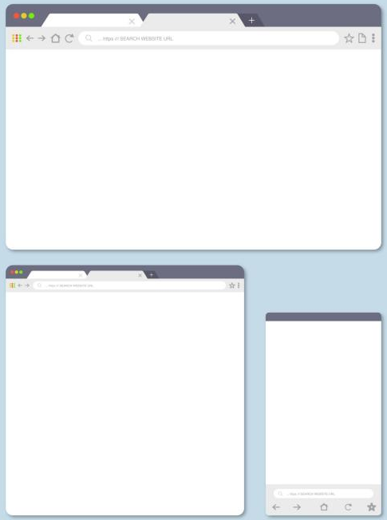
driver.close() #close the window
driver.switch_to.window(parent) #Go to parent window
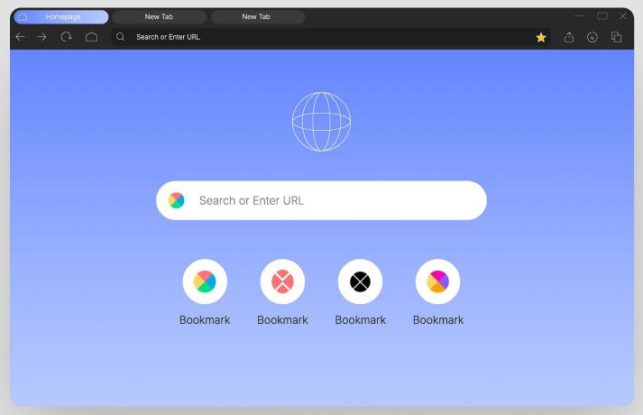

New Tabs

B. SWITCHING LOGIC:
New Browser window
driver.find_element(By.ID, "openwindow").click()
for handle in driver.window_handles:
if handle != parent:
driver.switch_to.window(handle)
print("Child Window Title:", driver.title)
driver.close() # Close tab

# Switch back to parent window
driver.switch_to.window(parent)

5. WORKING WITH KEYBOARD EVENTS
Keyboard events (Enter, Tab, Escape, Shortcuts like Ctrl + A) are executed via ‘Keys’ class or ‘ActionChains’.

A. Keys
- IMPORT REQUIREMENTS:
from selenium.webdriver.common.keys import Keys

- DIRECT KEY PRESSES:
element.send_keys("Query Text", Keys.ENTER)
element.send_keys(Keys.TAB)
element.send_keys(Keys.BACKSPACE)
element.send_keys(Keys.DELETE)
element.send_keys(Keys.ESCAPE)
element.send_keys(Keys.CONTROL, “a”)
element.send_keys(Keys.CONTROL, “c”)
element.send_keys(Keys.CONTROL, “v”)
element.send_keys(Keys.ARROW_UP)
element.send_keys(Keys.ARROW_DOWN)
element.send_keys(Keys.ARROW_LEFT)
element.send_keys(Keys.ARROW_RIGHT)
element.send_keys(Keys.SHIFT, Keys.TAB)

B. ActionChains
- IMPORT REQUIREMENTS:
from selenium.webdriver.common.action_chains import ActionChains
#create object of the class
actions = ActionChains(driver)
# most action chain need .perform() to perform tasks actions.click(element)

- COMBINATION SHORTCUTS (ActionChains):

#Mouse hover. Use: Hover menus, tooltips, dropdown menus.
menu = driver.find_element(By.ID, "menu")
actions.move_to_element(menu).perform()

#Right click
button = driver.find_element(By.ID, "button")
actions.context_click(button).perform()

#Double click
actions.double_click(button).perform()

#Normal click
actions.click(button).perform()

#Drag and Drop
HTML
<div id="source">Drag Me</div>
<div id="target">Drop Here</div>

#Python
source = driver.find_element(By.ID, "source")
target = driver.find_element(By.ID, "target")

actions.drag_and_drop(source, target).perform()

#Click and Hold
element = driver.find_element(By.ID, "box")
actions.click_and_hold(element).perform()

#Release Mouse; useful for drag operations
actions.release().perform()

#Execute the action stored in an actionchain object
actions.click(element).perform()

# Select All (Ctrl+A) and Backspace
actions.click(element)
actions.key_down(Keys.CONTROL)
actions.send_keys("a")
actions.key_up(Keys.CONTROL)
actions.send_keys(Keys.BACKSPACE)
actions.perform()

actions .click(element) \
.key_down(Keys.CONTROL) \
.send_keys("a") \
.key_up(Keys.CONTROL) \
.send_keys(Keys.BACKSPACE) \
.perform()
# in python \ tells python continue statement of next line
actions.click(element) \
.key_down(Keys.CONTROL).send_keys("a").key_up(Keys.CONTROL) \
.send_keys(Keys.BACKSPACE).perform()

6. WORKING WITH SCROLLBAR
Scrolling in Selenium is performed via JavaScript execution or ActionChains.

A. SCROLL BY PIXEL OFFSET:
#Scroll down 500px ScrollBy Move 500 pixels down from current position.
driver.execute_script("window.scrollBy(0, 500);") # this is for using driver only
actions.scroll_by_amount(0, 500).perform() # this is for using actionchains only

# Go to an absolute position ScrollTo Go directly to position 500 pixels from the top.
driver.execute_script("window.scrollTo(0, 500);")

B. SCROLL TO BOTTOM OF PAGE:
driver.execute_script("window.scrollTo(0, document.body.scrollHeight);")

C. SCROLL TO TOP OF PAGE:
driver.execute_script("window.scrollTo(0, 0);")

D. SCROLL TO SPECIFIC ELEMENT:
# for driver
target = driver.find_element(By.ID, "target_id")
driver.execute_script("arguments[0].scrollIntoView(true);", target)

#for actionchain
element = driver.find_element(By.ID, "email")
actions.scroll_to_element(element).perform()

E. SELENIUM 4 ACTIONCHAINS SCROLL:
ActionChains(driver).scroll_to_element(target).perform()

F. SCROLL FROM ORIGIN ACTIONCHAINS
from selenium.webdriver.common.action_chains import ActionChains
from selenium.webdriver.common.actions.wheel_input import ScrollOrigin
origin = ScrollOrigin.from_element(element)
ActionChains(driver).scroll_from_origin(origin, 0, 500).perform()

7. WORKING WITH DRAG AND DROP
Moving elements from a source location to a target container requires ‘ActionChains’.

A. SYNTAX (Direct drag_and_drop):
HTML
<div id="source">Drag Me</div>
<div id="target">Drop Here</div>
#Python
source = driver.find_element(By.ID, "draggable")
target = driver.find_element(By.ID, "droppable")
actions = ActionChains(driver)
actions.drag_and_drop(source, target).perform()

B. ALTERNATIVE MANUAL SEQUENCE:
actions.click_and_hold(source).move_to_element(target).release().perform()

8. HANDLING IFRAMES
An iframe (`<iframe>`) embeds an external HTML document inside the parent page.
An iframe (Inline Frame) is an HTML element that displays another webpage inside the current webpage. Selenium can not directly interact with the elements inside an iframe from the main page
Example
HTML
<iframe id="myFrame" src="frame.html"></iframe>
Inside frame.html
<input id="username" type="text">
<button id="login">Login</button>

A. SWITCHING INTO IFRAME:
By ID or Name: driver.switch_to.frame("iframe_id_or_name") # here id = myFrame
By Index: driver.switch_to.frame(0) # indexing start from 0
By WebElement: iframe_elem = driver.find_element(By.ID, "myFrame") # locate element
driver.switch_to.frame(iframe_elem) # switch to it

B. SWITCHING BACK:
To Parent Frame: driver.switch_to.parent_frame() # go to the just parent previous page
To Default Content: driver.switch_to.default_content() # go to the very first main page

9. FIND THE STATE OF A WEB ELEMENT (DISABLED AND ENABLED)
Evaluating element states before interaction avoids ‘ElementNotInteractableException’ error.
Selenium provides the is_enabled() method to check whether a web element is enabled or disabled.

A. METHODS:
- ‘is_displayed()’: Returns True if element is visible on page.
- ‘is_enabled()’: Returns True if element is enabled/interactive.
- ‘is_selected()’: Returns True if radio button or checkbox is checked.

B. EXAMPLE LOGIC:
elem = driver.find_element(By.ID, "submit_btn")
if elem.is_displayed() and elem.is_enabled(): # Disable the enable button
elem.click()

10. GET THE TEXT ON ELEMENT, GET VALUE OF ELEMENT ATTRIBUTE
Extracting textual content and HTML metadata from DOM elements.
.text Gets visible text
.get_attribute() Gets the value of an HTML attribute

A. GET TEXT ON ELEMENT:
Retrieves visible inner text between opening and closing HTML tags (‘<p>Text</p>’).
Syntax: text_content = element.text

HTML code All this case .text can be used
<h2 id="title">Welcome to Selenium</h2> <h2>Welcome</h2>
<button id="login">Login</button> <p>Hello</p>
<button>Login</button>
#python <a>Google</a>
title = driver.find_element(By.ID, "title") <div>Welcome</div>
print(title.text)

B. GET VALUE OF ELEMENT ATTRIBUTE:
Retrieves specific HTML attribute values (value, href, src, class, id, name).
Syntax: attr_val = element.get_attribute("attribute_name")

All this case .get_attribute() can be used
HTML Attribute | Example HTML | Selenium
id | <input id="username"> | element.get_attribute("id")
name | <input name="user"> | element.get_attribute("name")
class | <div class="login-box"> | element.get_attribute("class")
value | <input value="Diptarka"> | element.get_attribute("value")
type | <input type="text"> | element.get_attribute("type")
placeholder | <input placeholder="Enter name"> | element.get_attribute("placeholder")
href | <a href="https://google.com"> | element.get_attribute("href")
src | <img src="logo.png"> | element.get_attribute("src")
title | <button title="Submit form"> | element.get_attribute("title")
alt | <img alt="Company Logo"> | element.get_attribute("alt")
style | <div style="color:red"> | element.get_attribute("style")
role | <button role="button"> | element.get_attribute("role")
aria-label | <button aria-label="Close"> | element.get_attribute("aria-label")
disabled | <button disabled> | element.get_attribute("disabled")
checked | <input checked> | element.get_attribute("checked")
readonly | <input readonly> | element.get_attribute("readonly")
required | <input required> | element.get_attribute("required")
maxlength | <input maxlength="20"> | element.get_attribute("maxlength")
min | <input min="1"> | element.get_attribute("min")
max | <input max="100"> | element.get_attribute("max")
pattern | <input pattern="[A-Z]+"> | element.get_attribute("pattern")
action | <form action="/login"> | element.get_attribute("action")
method | <form method="post"> | element.get_attribute("method")

C. EXAMPLE USAGE:
heading = driver.find_element(By.TAG_NAME, "h1").text
input_val = driver.find_element(By.ID, "name").get_attribute("value")
link_href = driver.find_element(By.ID, "home_link").get_attribute("href")

